Case report
Metachronous cutaneous squamous cell carcinoma in a African woman with oculocutaneous albinism: diagnostic and management challenges in a resource-limited setting. A case report
Dr. Elizabeth Msangi^{1,2}, Dr. Silas Frank Gamba¹, Dr. Evelyna Gasper^{1*}, Dr. Emmanuel Lusomi¹, Dr. Halima Suleimani¹, Dr. Deogratias Mwanjamila³, Dr. Andrew Foi², Dr. Lorna Kasyanju², Prof. Muhammad Bakari Kambi^{1,2}

¹ Department of Internal Medicine, Muhimbili University of Health and Allied Sciences, Dar es Salaam, Tanzania
² Department of Dermatology, Muhimbili National Hospital, Dar es Salaam, Tanzania
³ Department of Pathology, Muhimbili University of Health and Allied Sciences, Dar es Salaam, Tanzania
*Corresponding author: Evelyna Gasper, Department of Internal Medicine, Muhimbili University of Health and Allied Sciences, Dar es Salaam, Tanzania. Email: evegasper21@gmail.com

Word count: Abstract 282; Main Text (Background to Conclusions) 1812.
Figures: 3. Tables: 0. References: 19.

Abstract

Background: Oculocutaneous albinism (OCA) is a group of autosomal recessive disorders of melanin biosynthesis that leaves the skin highly vulnerable to ultraviolet-induced keratinocyte carcinoma. In sub-Saharan Africa, where the prevalence of OCA is among the highest in the world, squamous cell carcinoma (SCC) is the predominant skin cancer in people with albinism; it arises early, is often multiple and is a leading cause of premature death. Second primary tumours are common, yet follow-up in the region is frequently lesion-focused and incomplete.
Case presentation: A 48-year-old Tanzanian woman with OCA and prolonged occupational sun exposure presented with a five-month history of a non-healing ulcerated plaque on the left cheek. Three years earlier she had undergone right orbital exenteration for an eyelid SCC with perineural invasion and involved margins, followed by four cycles of chemotherapy and external-beam radiotherapy, without margin re-excision or post-treatment imaging. Clinical examination showed ulceration, a rolled border, and arborising vessels suggested nodular basal cell carcinoma, but histopathology demonstrated an invasive keratinising SCC arising from the overlying epidermis. Because Mohs micrographic surgery is unavailable, the tumour was excised with a 6 mm peripheral margin and histologically clear margins, the surrounding actinic keratoses were treated with cryotherapy.
Conclusions: In people with albinism, a first SCC marks a chronically ultraviolet-damaged, field-cancerised skin in which further primary tumours are expected, and any new indurated or ulcerated lesion warrants biopsy regardless of its clinical or dermoscopic appearance. Where margin-controlled surgery is unavailable, histologically confirmed clearance with guideline-based margins, delayed reconstruction when needed, and structured whole-skin surveillance are the realistic priorities. Photoprotection programmes, community-level early detection and multidisciplinary cancer care pathways for people with albinism are urgently needed across sub-Saharan Africa.

Keywords: Albinism, oculocutaneous; Carcinoma, squamous cell; Neoplasms, second primary; Field cancerisation; Dermoscopy; Perineural invasion; Tanzania; Case report

Background
Oculocutaneous albinism (OCA) comprises a genetically heterogeneous group of autosomal recessive disorders characterised by markedly reduced or absent melanin in the skin, hair and eyes (1). Melanin is the principal endogenous photoprotectant, and its absence exposes the epidermis to cumulative ultraviolet (UV)-induced DNA damage and a substantially increased risk of keratinocyte carcinoma (2). The prevalence of OCA in African countries averages around 1 in 4,000 (range 1 in 1,755 to 1 in 7,900) and is far higher in some population isolates (3); in Tanzania, estimates of 1 in 1,400 to 1 in 2,500 are among the highest reported anywhere (4). Intense equatorial UV radiation, outdoor livelihoods, and limited access to photoprotection combine to produce early-onset, multiple and often advanced skin cancers (5, 6), of which squamous cell carcinoma (SCC) is the most frequent (7, 8). Skin cancer is thought to be the major cause of premature death among people with albinism in Africa (4, 9).
Synchronous and metachronous keratinocyte carcinomas are common in people with albinism but poorly documented in East Africa, particularly regarding tumour classification and high-risk management without margin-controlled surgery. We describe a case of Tanzanian woman with OCA who developed a second cutaneous SCC three years after incompletely excised, perineurally invasive eyelid SCC. Despite BCC-like clinical and dermoscopic features, histology confirmed SCC, highlighting diagnostic pitfalls, recurrence risks, and lifelong whole-skin surveillance.

Case presentation

History
A 48-year-old Tanzanian woman with OCA, a subsistence farmer with prolonged daily sun exposure, presented with a three-year history of multiple, progressively enlarging skin lesions on the face, neck and the extensor surfaces of the upper and lower limbs. The lesions had begun as small, pruritic, scaly brown papules and had steadily increased in number and extent. Over the preceding five months, one lesion on the left lower side of the cheek had become indurated and then ulcerated. She denied bleeding, discharge or constitutional symptoms.
She reported inconsistent use of sun-protective clothing and sunscreen and had never participated in a routine skin surveillance programme. She neither smoked nor consumed alcohol, and HIV testing was negative. Her oncological history included right orbital exenteration three years earlier for eyelid keratinising SCC with perineural invasion and involved surgical margins (Figure 1). She subsequently received four cycles of chemotherapy and external-beam radiotherapy. Financial constraints prevented margin re-excision and post-treatment cross-sectional imaging.
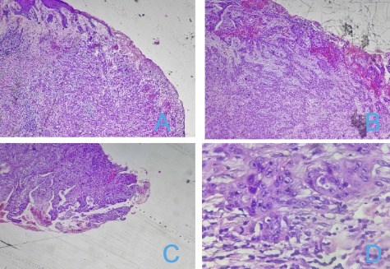
Figure 1. Histopathology of the right orbital exenteration specimen from three years earlier: (A, B) invasive eyelid SCC with stromal invasion and inflammation; (C) tumour at the resection margin; (D) pleomorphic, hyperchromatic squamous cells with prominent nucleoli and increased nuclear-to-cytoplasmic ratio.

Examination
Examination revealed classical OCA features: straw-coloured hair, hypopigmented eyebrows, a yellowish-orange iris and left-eye rotatory nystagmus. The right orbital cavity was healed. The nape showed wrinkled, leathery, mottled skin suggestive of solar elastosis. Rough, scaly, erythematous papules and indurated hyperkeratotic plaques affected the face and extensor limbs, consistent with extensive actinic keratoses.
A 2 × 2 cm indurated, ulcerated plaque with an irregular, rolled border and erythematous base was present over the left lower lateral cheek near the mandibular angle. It was firm, non-tender and mobile, with a crusted satellite plaque and surrounding erythema (Figure 2). Dermoscopy revealed central ulceration, a moist pink base, peripheral yellow-amber crust, arborising vessels, pinpoint haemorrhages and shiny white structures. Systemic examination was unremarkable.
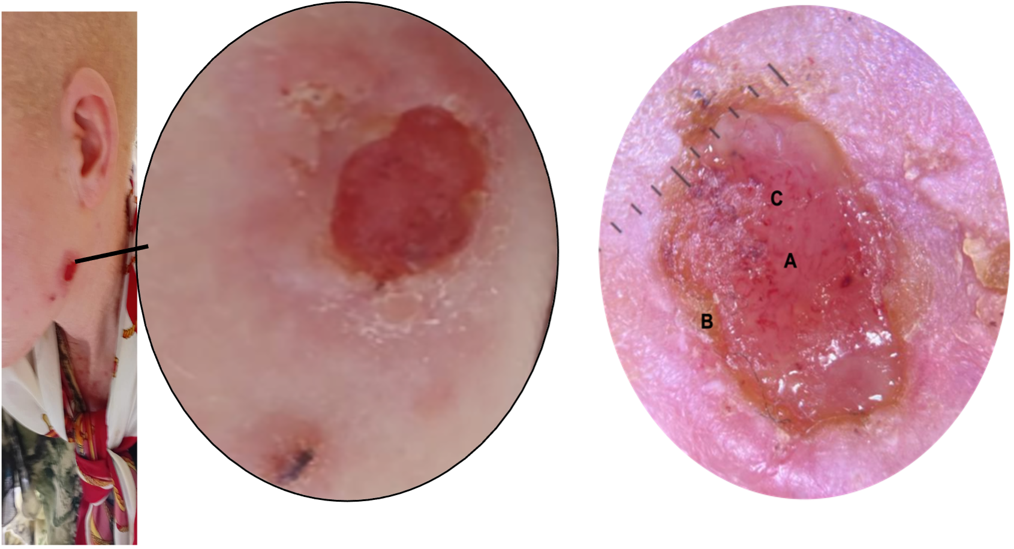
Figure 2. Clinical and dermoscopic features of the neck lesion: ulcerated plaque with an inferior crusted satellite lesion (left), close-up (centre), and dermoscopy (right) showing (A) central ulceration, (B) peripheral yellow-amber serous crust and (C) arborising vessels with pinpoint haemorrhages.

Investigations
Full blood count and coagulation profile were normal. Biopsy confirmed invasive cutaneous SCC, overturning the clinical suspicion of BCC (Figure 3). Low-power sections showed invasive nests of keratinising squamous epithelium with dermal infiltration and keratin pearls. High-power examination revealed pleomorphic, hyperchromatic polygonal cells with intercellular bridges, increased nuclear-to-cytoplasmic ratios and prominent nucleoli, resembling the previous eyelid tumour. Given the distinct anatomical site, three-year interval, epidermal origin and surrounding actinic keratoses, the lesion was classified as a metachronous second primary SCC rather than recurrence. However, previous perineural invasion and involved margins warranted dedicated assessment for persistent or recurrent periocular disease.
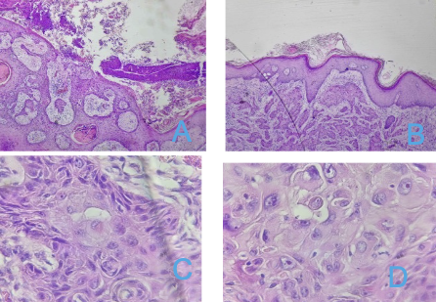
Figure 3. Histopathology of the new lesion. (A, B) Low-power views showing invasive keratinising squamous cell carcinoma nests, dermal infiltration and keratin pearls. (C, D) High-power views showing pleomorphic, hyperchromatic polygonal cells with intercellular bridges, increased nuclear-to-cytoplasmic ratios, vesicular chromatin and prominent nucleoli.

Treatment
Mohs micrographic surgery is not available in our setting; therefore, the neck tumour was excised with a 6 mm clinical margin. Histology confirmed clear peripheral and deep margins. Recovery was uneventful, with satisfactory wound healing at discharge. Surrounding actinic keratoses were treated with liquid nitrogen cryotherapy. Counselling covered strict photoprotection and skin self-examination. Given the previous margin-positive eyelid SCC with perineural invasion, orbital MRI and formal ophthalmological review were arranged at discharge to assess for residual or recurrent periocular disease. Lifelong dermatological follow-up with whole-skin examination was scheduled every three months.

Discussion

Skin cancer in people with albinism in sub-Saharan Africa
People with oculocutaneous albinism (OCA) in sub-Saharan Africa have an increased risk of cutaneous squamous cell carcinoma (SCC), estimated to be up to 1,000 times that of the general population, owing to reduced melanin-mediated photoprotection, intense ultraviolet exposure and barriers to preventive care (2, 5, 9). A systematic review of 23 studies involving 540 African people with albinism identified 695 skin cancers: 64% were SCC (95% CI 50–77%) and 31% BCC (95% CI 19–45%), with substantial heterogeneity (I² = 89%). SCC predominated in surgical series, whereas BCC was more common in surveillance programmes detecting earlier lesions (8). Tanzanian studies also report a predominance of head and neck tumours, with SCC outnumbered BCC by up to 1.2 to 1 (4, 7). Our patient's second head and neck SCC and extensive actinic keratoses reflect this pattern.
The neck lesion highlights the limitations of clinical and dermoscopic diagnosis in actinically damaged skin. Although ulceration, a rolled border, arborising vessels and shiny white structures suggested BCC, histopathology confirmed invasive SCC with keratin pearls and intercellular bridges. In a study of 154 keratinocyte carcinomas, SCC was more often misdiagnosed as BCC than vice versa; dermoscopy improved accuracy but did not resolve all cases (11). Distinguishing these tumours is important because SCC has metastatic potential and requires requires wider margins and closer follow-up than BCC (10-12). As pigment-related diagnostic cues may be less apparent in people with albinism, suspicious, indurated, ulcerated or enlarging lesions should be biopsied rather than diagnosed by clinical or dermoscopic appearance alone.

A second primary tumour in field-cancerised skin
Extensive actinic keratoses on the patient's face, neck and limbs indicate field cancerisation, in which chronically UV-damaged skin develops multiple independent tumours (13). By the classical criteria for multiple primary malignancies, the neck lesion is best classified as a metachronous second primary SCC: it arose three years after the eyelid tumor at a separate site, and histology showed continuity with the overlying epidermis. Similar cytomorphology does not establish a clonal relationship. However, because the lesion was within the regional drainage territory of the previous periocular SCC, metastasis remained a differential diagnosis. Imaging of the parotid and cervical nodal basins would have helped assess regional disease and should be considered in this setting (11, 12).
Patients with keratinocyte carcinoma remain at risk of further tumours. In a prospective cohort, the five-year risk of another tumour was 40.7% after the first and 82.0% after a second or subsequent tumour (14). The patient's previous eyelid SCC had perineural invasion and involved margins, both adverse features associated with increased risks of recurrence and spread. Complete excision with clear margins is therefore preferred, and MRI is recommended when perineural extension is suspected (15). Incomplete excision occurs in approximately 13% of cutaneous SCC cases and is associated with increased risks of recurrence, metastasis and disease-specific mortality. Re-excision may identify residual tumour, and recurrence is more frequent when re-excision margins remain involved than when they are clear (16, 17). Incomplete excision occurs in approximately 13% of cutaneous SCC cases and is associated with increased risks of recurrence, metastasis and disease-specific mortality. Re-excision may identify residual tumour, and recurrence is more frequent when re-excision margins remain involved than when they are clear (11, 12). In this case, the patient received adjuvant radiotherapy, but re-excision and post-treatment imaging were not performed. The benefit of the four chemotherapy cycles remains uncertain, as cytotoxic chemotherapy has no established routine role in the adjuvant treatment of cutaneous SCC (12, 18).

Treatment without Mohs surgery and barriers to follow-up
Mohs surgery and other methods of complete peripheral and deep margin assessment can improve margin control in high-risk SCC, but is not available in most resource-limited settings (19). Conventional bread-loaf sectioning examines only a small fraction of the margin surface (16), making appropriate clinical margins and histological confirmation of clearance important. UK guidance recommends at least 6 mm margins for high-risk SCC, while European guidance recommends 6–10 mm The 6 mm margin used in this case achieved clear peripheral and deep margins. Staged excision with paraffin-section assessment and delayed reconstruction may be an alternative that in these settings could adopt.
Structural barriers also affect timely diagnosis and continuity of care. In northern Tanzania, 42.2% of patients did not complete treatment because of financial constraints, and local recurrence after surgery was 30% (4). Our patient's delayed imaging and re-excision reflect similar barriers. Outreach skin-care programmes have shown that community-based screening can detect actinic damage and early tumours in people with albinism, and structured photoprotection with protective clothing, hats, and sunscreen reduces new actinic lesions (2). Cryotherapy of actinic keratoses, as used here, is an inexpensive field-directed treatment that can be delivered at district level. Integrating these measures with education in skin self-examination, training of primary health workers to recognise and refer early lesions, and teledermatology links to referral centres could improve access to early diagnosis and ongoing follow-up.

Limitations
This case report is limited by the absence of imaging of the parotid and cervical nodal basins and molecular or immunohistochemical testing to distinguish a second primary tumour from metastasis. The short follow-up period also limits assessment of recurrence and long-term outcomes.

Conclusions
In people with OCA, a first cutaneous SCC signals a field-cancerised skin in which further primary tumours are expected, and a new indurated or ulcerated lesion should be biopsied whatever its clinical or dermoscopic appearance. Involved margins and perineural invasion in a periocular SCC call for re-excision or, where that is impossible, adjuvant radiotherapy and imaging surveillance. Where margin-controlled surgery is unavailable, guideline-based margins with histological confirmation of clearance, delayed reconstruction when necessary, field-directed treatment of actinic keratoses and lifelong whole-skin surveillance are the realistic priorities. Structured photoprotection, community-level early detection and multidisciplinary cancer care pathways for people with albinism are urgently needed to reduce the burden of preventable skin cancer in Tanzania and across sub-Saharan Africa.

Abbreviations
AK: actinic keratosis; BCC: basal cell carcinoma; CI: confidence interval; HIV: human immunodeficiency virus; MRI: magnetic resonance imaging; OCA: oculocutaneous albinism; SCC: squamous cell carcinoma; UV: ultraviolet

Declarations

Ethics approval and consent to participate
This report describes the routine clinical care of a single patient, who gave written informed consent for treatment and for the reporting of her case.

Consent for publication
Written informed consent was obtained from the patient for publication of this case report and any accompanying images.

Availability of data and materials
All data generated or analysed during this study are included in this published article.

Competing interests
The authors declare that they have no competing interests.

Funding
The authors received no specific funding for this work.

Authors' contributions
EM, SFG and EG conceived the report and drafted the manuscript. LK, AF, MBK, EM, SFG, EL and HS were involved in the clinical care of the patient and collected the clinical data and photographs. SFG, DM performed the histopathological evaluation and prepared the photomicrographs. EM, EG and SFG reviewed the literature and revised the manuscript. All authors read and approved the final manuscript.

Acknowledgements
The authors thank the patient for her consent to the publication of her case.

References
1. Fernández A, Hayashi M, Garrido G, Montero A, Guardia A, Suzuki T, et al. Genetics of non-syndromic and syndromic oculocutaneous albinism in human and mouse. Pigment Cell & Melanoma Research. 2021;34(4):786-99.
2. Wright CY, Norval M, Hertle RW. Oculocutaneous albinism in sub-Saharan Africa: adverse sun-associated health effects and photoprotection. Photochemistry and Photobiology. 2015;91(1):27-32.
3. Kromberg JGR, Flynn KA, Kerr RA. Determining a worldwide prevalence of oculocutaneous albinism: a systematic review. Investigative Ophthalmology & Visual Science. 2023;64(10):14.
4. Mabula JB, Chalya PL, McHembe MD, Jaka H, Giiti G, Rambau P, et al. Skin cancers among albinos at a university teaching hospital in Northwestern Tanzania: a retrospective review of 64 cases. BMC Dermatology. 2012;12:5.
5. Hong ES, Zeeb H, Repacholi MH. Albinism in Africa as a public health issue. BMC Public Health. 2006;6:212.
6. Kromberg JGR, Kerr R. Oculocutaneous albinism in southern Africa: historical background, genetic, clinical and psychosocial issues. African Journal of Disability. 2022;11:a877.
7. Kiprono SK, Chaula BM, Beltraminelli H. Histological review of skin cancers in African albinos: a 10-year retrospective review. BMC Cancer. 2014;14:157.
8. Onyishi NT, Ohayi SR. Prevalence of squamous and basal cell carcinomas in African albino skin cancer lesions: a systematic review and meta-analysis of proportion. Journal of Skin Cancer. 2022;2022:5014610.
9. Lekalakala PT, Khammissa RAG, Kramer B, Ayo-Yusuf OA, Lemmer J, Feller L. Oculocutaneous albinism and squamous cell carcinoma of the skin of the head and neck in sub-Saharan Africa. Journal of Skin Cancer. 2015;2015:167847.
10. Ryu TH, Kye H, Choi JE, Ahn HH, Kye YC, Seo SH. Features causing confusion between basal cell carcinoma and squamous cell carcinoma in clinical diagnosis. Annals of Dermatology. 2018;30(1):64-70.
11. Keohane SG, Botting J, Budny PG, Dolan OM, Fife K, Harwood CA, et al. British Association of Dermatologists guidelines for the management of people with cutaneous squamous cell carcinoma 2020. British Journal of Dermatology. 2021;184(3):401-14.
12. Stratigos AJ, Dessinioti C, Garbe C, Lebbe C, Amaral T, Bataille V, et al. European consensus-based interdisciplinary guideline for invasive cutaneous squamous cell carcinoma: Part 2. Treatment - update 2026. European Journal of Cancer. 2026;243:116764.
13. Slaughter DP, Southwick HW, Smejkal W. "Field cancerization" in oral stratified squamous epithelium; clinical implications of multicentric origin. Cancer. 1953;6(5):963-8.
14. Wehner MR, Linos E, Parvataneni R, Stuart SE, Boscardin WJ, Chren MM. Timing of subsequent new tumors in patients who present with basal cell carcinoma or cutaneous squamous cell carcinoma. JAMA Dermatology. 2015;151(4):382-8.
15. Tong JY, Huilgol SC, James C, Rajak S, Selva D. Perineural invasion and perineural spread in periocular squamous cell carcinoma. Eye (London). 2023;37(5):875-84.
16. Genders RE, Marsidi N, Michi M, Henny EP, Goeman JJ, van Kester MS. Incomplete excision of cutaneous squamous cell carcinoma; systematic review of the literature. Acta Dermato-Venereologica. 2020;100(6):adv00084.
17. Bovill ES, Banwell PE. Re-excision of incompletely excised cutaneous squamous cell carcinoma: histological findings influence prognosis. Journal of Plastic, Reconstructive & Aesthetic Surgery. 2012;65:1390-5.
18. Alam M, Armstrong A, Baum C, Bordeaux JS, Brown M, Busam KJ, et al. Guidelines of care for the management of cutaneous squamous cell carcinoma. Journal of the American Academy of Dermatology. 2018;78(3):560-78.
19. Lansbury L, Bath-Hextall F, Perkins W, Stanton W, Leonardi-Bee J. Interventions for non-metastatic squamous cell carcinoma of the skin: systematic review and pooled analysis of observational studies. BMJ. 2013;347:f6153.

